SHORT URL GENERATOR
@CREATIVITY THINK (9483175986/7019689991)

ABSTRACT:
The Short URL Generator is a web-based application designed to create compact and trackable short links for websites, marketing campaigns, and digital communication. It provides users with an intuitive interface to generate short URLs, track click analytics, and manage link expiry. Administrators can monitor total usage, system performance, and export analytics data through a comprehensive dashboard. Built with Django and the Django Rest Framework for backend processing and React with axios and Recharts for the frontend, the system ensures secure, reliable, and efficient URL shortening with integrated real-time analytics..

INTRODUCTION OF THE PROJECT:
In the digital era, long URLs often create difficulties in sharing, tracking, and managing links across platforms. Businesses and individuals require shorter, more manageable links that also provide insights into user engagement. Traditional manual tracking methods lack detailed analytics and expiration control. The Short URL Generator resolves these challenges by offering a streamlined approach to shortening links, monitoring click statistics, setting custom expiry dates, and providing dashboard insights. It enhances user experience, supports marketing strategies, and improves overall link management efficiency..

PROJECT OBJECTIVES:

• Provide users with the ability to create short and meaningful URLs
• Enable click tracking and analytics for each link
• Allow configurable expiry dates for short links
• Provide an intuitive dashboard for users and administrators
• Store and manage links with secure backend APIs
• Support administrators with exportable usage reports
• Enhance marketing performance through link insights
• Maintain high scalability and reliability for heavy link usage

PROBLEM OF THE STATEMENT:
Long URLs are difficult to share, track, and manage across multiple digital platforms. Marketing teams struggle to analyze user engagement without proper click tracking tools, while individuals face difficulties in creating meaningful compact links. Existing URL shorteners may not provide detailed analytics or customized expiry settings. The Short URL Generator addresses these issues by offering a centralized and automated system for shortening long URLs, tracking views, setting expiry dates, and providing analytics through dashboards. This ensures efficiency, transparency, and data-driven insights for link management..

MOTIVATION OF THE PROJECT:
• To simplify link sharing and improve usability across platforms
• To support marketers with analytics-driven insights
• To create a structured and reliable link tracking system
• To provide security via time-based link expiry
• To build a scalable solution accessible to individuals and businesses
• To automate click tracking and store accurate usage statistics

BLOCK DAIGRAM OF PROJECT:

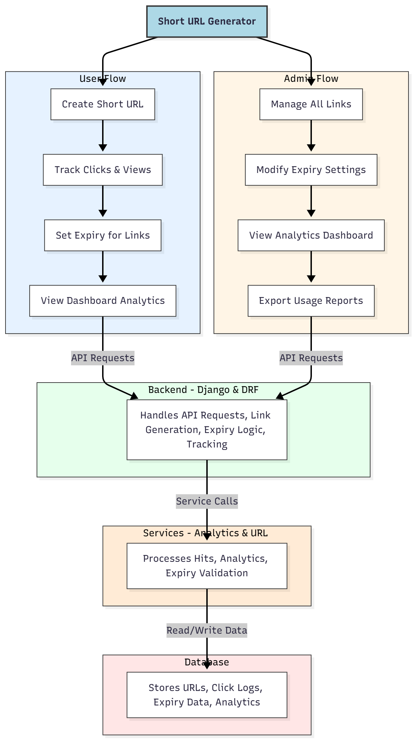

WORKING OF THE PROJECT:
The system begins when a user provides a long URL through the interface. The backend generates a unique short code and stores it along with expiry details in the database. When the short link is accessed, the backend validates expiry, records click data, and redirects the user to the original long URL. The analytics service processes hit counts, timestamps, and usage patterns to generate dashboards for users and administrators. Admins can manage, modify, or delete links, review detailed analytics, and export usage data. This workflow ensures efficient link generation, accurate tracking, and reliable expiry-based control..

SOFTWARE REQUIREMENT:
- Backend:
  - Python 3.x
  - Django
  - Django REST Framework
  - SQLite/PostgreSQL
- Frontend:
  - Node.js and npm
  - React.js
  - Axios
- Development Tools:
  - Visual Studio Code
  - Postman (for testing APIs)
  - Git/GitHub (for version control)
- Server/Deployment (Optional):
  - Gunicorn, Nginx, or Heroku/AWS for hosting

ADVANTAGES OF THE PROJECT:

• Enables quick creation of clean, short URLs
• Provides real-time click tracking and detailed analytics
• Allows configurable expiry for secure link usage
• Supports dashboard visualization for insights
• Enhances digital marketing efficiency
• Reduces complexity in sharing long URLs
• Helps administrators monitor system-wide usage
• Enables exportable reports for analysis and audits

APPLICATIONS OF THE PROJECT:
• Digital marketing and campaign tracking
• Social media link sharing
• E-commerce product promotions
• Corporate internal link management
• Event registration and tracking
• Mobile application deep linking
• Short link analytics for businesses
• Streamlined sharing for education or research

REFERENCES:

- Django REST Framework Documentation — Django Software Foundation. Django Documentation. Available: https://docs.djangoproject.com/
- Django REST Framework. DRF Documentation. Available: https://www.django-rest-framework.org/
- React. React Official Documentation. Available: https://reactjs.org/docs/getting-started.html
- Redux. Redux Documentation. Available: https://redux.js.org/introduction/getting-started
- PostgreSQL Global Development Group. PostgreSQL Documentation. Available: https://www.postgresql.org/docs/
- MySQL. MySQL Reference Manual. Available: https://dev.mysql.com/doc/
- Git. Git Documentation. Available: https://git-scm.com/doc
- Node.js. Node.js Documentation. Available: https://nodejs.org/en/docs/
- Axios. Axios Documentation. Available: https://axios-http.com/docs/intro
- Socket.io Documentation – https://socket.io/docs/

